Interpreting sources

Interpreting Written Sources

Interpreting a source requires you to demonstrate that you understand the overall message of a source. This requires you to think a bit more about what a source says than is required for simple comprehension. However, interpretation allows you to draw a more confident conclusion when you evaluate a source, particularly in regards to its relevance to your topic.

What is 'interpretation'?

Interpretation is the ability to identify implicit (‘hidden’ or less obvious) meanings in historical sources.

You will need to do this most often with visual sources that take time to interpret. However, some written sources will often not be explicit enough for you and they will require your interpretation of the information.

How do I interpret a written source?

To successfully interpret what a written source says, follow these steps:
- Read the source two or three times. (Reading it once is often not enough).
- Identify the main message of the source. (e.g. What is the most important point made in the writing?).
- Highlight the key phrases used by the author. (Usually two to three key statements is enough).
- Summarise the main message in your own words. (This will usually require you to use indirect quotes).
- Read over your summary to make sure everything you have written was stated by the source. (e.g. Don't include your own opinion in your summary).
- Reread your summary to make sure you have successfully paraphrased the source and have not simply copied their exact words.

What do I do with my interpretation?

Identifying the message of a document shows that you understand the source, which means that you can use it as an indirect quote in your historical writing.

Your interpretation also helps you in your analysis and evaluation of the source. For example, identifying the source's message can help you ascertain:
- The purpose of the writing
- The motive of the author
- The relevance of the source to your argument
- The accuracy of the information presented in the source

Interpreting Photographs
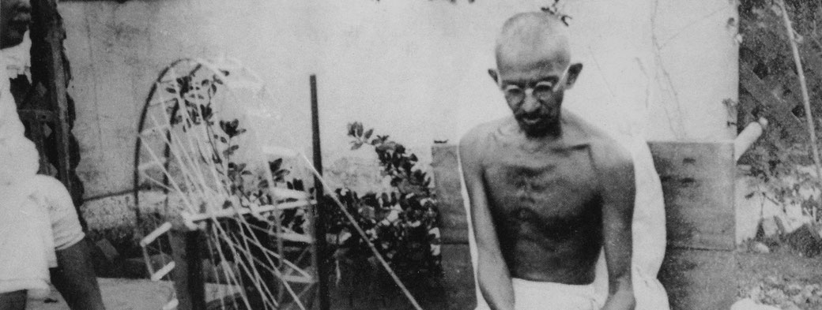"Gandhi spinning" by gandhiserve.org. Public Domain. Source: https://commons.wikimedia.org/wiki/File:Gandhi_spinning.jpg

Interpreting a visual source, like a photograph, is very different to interpreting words on a page, which is the case with written sources. Therefore, you need to develop a different set of skills.

Photographs as sources

Photographs are very useful types of primary sources. They provide a rare glimpse of a particular second in time, which will never again be repeated. This is especially true for events that occurred before the development of television or digital technologies.

Many people assume that photographs are unbiased, accurate records of historical events. However, that is not always the case. Photographers took great care to create the exact images they wanted their audiences to see. Therefore, it is important to analyse photographs in order to identify the message the creator wanted their audience to understand.

If you want to gain a further appreciation of how different photographers can effect what an audience sees in an image, watch the clip below:

How do I identify the photo's message?

When people take a photograph, they make decisions about what to show in, or leave out of, the picture. Photographers do this by choosing the angle from which they take the shot and from what distance it will be taken, either close up or further away. Experienced photographers could then also edit their pictures later in order to change how the original image looked.

Therefore, to correctly interpret what the photographer intended their audience to understand from their image, we have to identify some specific information.

1. Identify the Main Subject: What are the most important people, locations or items in the image?
You can work out what the photographer wanted you to focus on by looking at what is in the centre of the photo, or what appears the largest. This is the main subject the creator wanted the audience to see.

2. Identify Minor Subjects: What appears in the background, behind or around the main subject?
Things of minor importance appear to support the main subject. The photographer wanted to also show these things to help you draw certain conclusions about the main subject.

3. Explain the Image Composition: At what distance from the main subject was the photograph taken?
If the photograph is a ‘close up’ of the main subject, the photographer wanted the audience to feel ‘part of the action’ or to be confronted by the image. If it was taken from further away, the photographer wanted the viewer to feel ‘detached’ from the action or to get a ‘bird’s eye view’ of things.

How do I interpret a photograph?

Once you have identified the main subject, the minor subjects and the composition of the photograph, you can begin to understand the photographer's intended message. Follow the next steps:
- The main subject is what the photographer wanted the audience to see. (e.g. They wanted them to see dead soldiers on the battlefield)
- The composition is how the photographer wanted the audience to feel about the main subject. (e.g. The image of the dead soldiers was taken 'close up' and they dominate the photo, so they wanted the audience to feel confronted by the main subject)
- The minor subjects may indicate how the photographer wanted the audience to react to what they see. (e.g. In the background there are other soldiers walking past the dead in an indifferent manner. So, the photographer wanted the audience to feel pity for the dead and motivate them to do something to commemorate their sacrifice.)

What do I do with my interpretation?

Not only does identifying the message of a photograph show that you understand the primary source, it also helps you in your analysis and evaluation of the source. For example, identifying the source's message can help you ascertain:
- The purpose of the photograph
- The motive of the photographer
- The relevance of the source to your argument
- The accuracy of the information presented in the image

Example

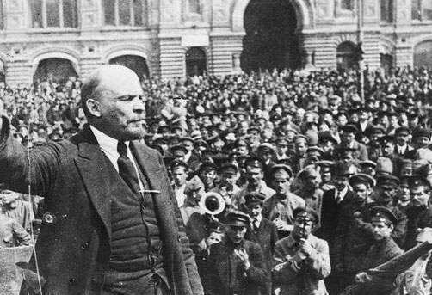
Demonstrating interpretation of a photograph in your writing:

The photograph of Lenin addressing a crowd shows him as the largest person in the image. It is clear that the photographer wanted the audience to focus on him. In the background can be seen a large number of people looking on admiringly, which may show that the photographer wanted their audience to also admire Lenin. Finally, the image was taken 'close up' to Lenin, which makes him a dominant figure of the photograph. Therefore, the creator wanted the viewer to feel confronted by who Lenin was and what he was saying during the speech. The dominant message of the photograph is that Lenin was a powerful speaker who drew the admiration of those around him and that his message was worth listening to.

Interpreting Political Cartoons
Interpreting a visual source, like a political cartoon, is very different to interpreting words on a page, which is the case with written sources. Therefore, you need to develop a different set of skills.

What is a 'political cartoon'?

Political cartoons are ink drawings created to provide a humorous or critical opinion about political events at the time of its creation. They were particularly popular in newspapers and magazines during the late 19th and early 20th centuries. However, they are still used by many newspapers, magazines and websites today.

While political cartoons can be funny, that is usually not their main purpose. They were primarily created to persuade their audience to take a particular view on a historical event. A successful political cartoon can change someone’s mind so that they ultimately agree with the cartoonist’s point of view.

Further information:

Learn more about the history of the political cartoon with this short YouTube clip:
If you've never seen a political cartoon before, you can see a contemporary one being made below:

How do I understand the meaning of a political cartoon?

Understanding what a historical political cartoon means can be difficult for us because we did not live through the political events the cartoons talk about. However, all political cartoons rely heavily upon a very simple visual ‘code’ rather than relying solely on words to convey their message. Once we learn how this visual code works, we can use it to ‘decode’ the specific message of a cartoon.

Political Cartoon Visual Codes
1. Caricature (Exaggeration)
Cartoonists intentionally draw people or characters with physical features that are larger than they naturally are. They do this in order to make a point. Usually the point is to highlight something about the character of a person. For example, if a person is drawn with a large, toothy grin, it can be a sign that they have evil intentions and are untrustworthy. Therefore, when interpreting a cartoon, look for any physical features that seem obviously exaggerated. Then, try to decide what point the creator was trying to make about the person.

2. Labelling
To help their audience understand what each person represents in their drawings, cartoonists often write a name on the major figures. Common names include famous politicians or countries. So when you’re interpreting a cartoon, look for the labels. You might need to do some background research to find out who the people are before you continue with your interpretation.

3. Symbolism

Cartoonists use simple objects, or symbols, that the general public would be familiar with. These symbols are used to represent important concepts or ideas. For example, using a ‘skull and crossbones’ could represent ‘death’ or ‘danger’. While you’re interpreting a cartoon, identify any symbols and try to work out what concept the image is meant to represent.

Here are some common symbols used in political cartoons, along with their common meanings:
Symbol | Meaning(s) | Symbol | Meaning(s) | Symbol | Meaning(s)
Anchor | safety, security | Bear | Russia | Bulldog | Great Britain
Chains | imprisonment, slavery | Crowd of People | unstoppable force | Cupid | love
Dollar Sign | money | Door/gate | access, entry | Dove | peace
Eagle | America | Grave Stone | death | Grim Reaper | Death
Hammer & Sickle | communism | Hare | carelessness, arrogance | Hourglass | limited time
Imperial Dragon | China | Kangaroo | Australia | Lamb | innocence
Octopus | greed | Ostrich | refusal to hear bad news | Owl | wisdom
Puppet | being controlled | Rainbow | hope, future | Rat | infection, disease
Red Star | communism | Rose | love | Samurai | Japan
Sheep | blind trust | Skull | death | Snake | evil, temptation
Spider/web | control, entrapment | Spiked Helmet | German | Star of David | Jews or Israel
Stars and Stripes | America | Swastika | Nazis, Nazism | Throne | power
Turtle | slow, vulnerable | Uncle Sam | America | Wall | division, separation
Woman with flag | a specific country | Woman with scales | justice | Young Child | naivety, innocence, victim
4. Captions

Another handy way that cartoonists convey important information to their audience is by providing a written explanation through a speech bubble in the cartoon itself or a caption at the bottom of the image. These words should help you understand the main historical event or issue that the image is based upon.

5. Stereotypes

It was very common for cartoonists to represent a particular group of people (usually in a very racist way) using stereotypes. A stereotype is an over-simpliﬁcation of what a particular racial group looks like. For example, Chinese people in the 19th century were drawn with a long pony-tail in their hair. Cartoonists use this so that audiences can readily identify which people group is the target of the cartoon. Getting to know common stereotypes can be quite confronting for us, since they can be very derogatory in nature. However, once you become familiar with common forms of stereotyping, you can identify the appropriate people group being targeted in a particular cartoon.

6. Analogies

An analogy is a comparison between two different things to highlight a particular similarity in ideas. Through the comparison of a complex political issue with more simplistic, 'everyday' scenarios with which the audience would be more familiar, a cartoonist can more easily convey their message.

Here are some common analogies and what they could mean in political cartoons:
Analogy | Meaning(s) | Analogy | Meaning(s) | Analogy | Meaning
Boss & Employee | Shows a power difference | Crucifixion | Shows an innocent sacrifice | Marriage | Shows a close relationship
Parent & Child | Shows dependence or care | Predator & Prey | Shows impending destruction | Shipwreck | Shows a disaster

How do I write an interpretation?

Once you have deconstructed the cartoon, now you can start creating your explanation. To do so, answer the following questions:

- Who or what is represented by the characterisation, stereotypes and symbols?
- Who or what have been labelled?
- What information is provided by the caption?
- What is the political issue being mentioned in the cartoon? (You may need to do some background research to discover this).
- What is the analogy that this cartoon is based upon?

Once you have answered these questions, you are ready to answer the final one:
- What did the cartoonist want the audience to think about the issue?

What do I do with my interpretation?

Identifying the message of a political cartoon shows that you understand the primary source, which means that you can use it as an indirect quote in your historical writing.

Your interpretation can also help you in your analysis and evaluation of the source. For example, identifying the source's message can help you ascertain:
- The purpose of the cartoon
- The motive of the cartoonist
- The relevance of the source to your argument
- The accuracy of the information presented in the image

Example

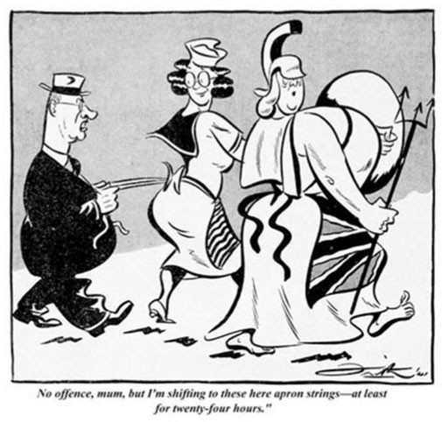
Frith, J. (31st December, 1941). 'No offence, mum...', The Bulletin.
Demonstrating interpretation of political cartoons in your writing:

The political cartoon by Frith makes a comment on Australia's changing diplomatic relationships between Great Britain and America during the Second World War. The cartoonist does this through the depiction of three main characters. The man on the left is clearly a caricature of Australian prime minister John Curtain, as he was commonly drawn with his distinctive hat and glasses. The woman on the right of the image is meant to symbolise Great Britain. This symbology is clear due to the use of the Union Jack, the flag of Great Britain, drawn upon her apron. Furthermore, she is depicted as the mythical figure of Britannia, a common representation of Britain. The second woman is meant to be America, as she is drawn with a stereotypical 1940s American hairstyle and clothing. This symolism is reinforced by the depiction of the stripes of the American flag drawn on her apron. The primary analogy the cartoon uses is the the idea of 'holding onto your mother's apron strings', which is used to describe a young child depending on their mother for comfort and security. This analogy is evident in the image caption which explicitly states that Curtain is "shifting to these here apron strings". The overall message of the cartoon is that Curtain is switching Australia's dependence from Great Britain to America for comfort and security. It is meant to be a satirical comment on the childish dependancy that Australia demonstrated during the early years of the Second World War.

Interpreting Propaganda Posters
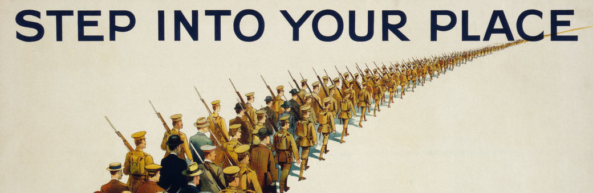Parliamentary Recruiting Committee. (1915). Step Into Your Place. London. © IWM (Art.IWM PST 0318). Source: https://www.iwm.org.uk/collections/item/object/27750

Interpreting a visual source, like a propaganda poster, is very different to interpreting words on a page, which is the case with written sources. Therefore, you need to develop a different set of skills.

What is a 'propaganda poster'?

Propaganda is an attempt to inﬂuence peoples’ opinions or behaviour through the use of specific images and words. It usually gives limited information which is heavily biased in its presentation. Propaganda typically achieves its aims by generating an emotional reaction in the viewer.

For much of the twentieth century, public posters were a common way for governments to use propaganda to persuade their citizens. They often relied upon simple images in order to manipulate people through fear or guilt.

How do I understand the meaning of a propaganda poster?

Understanding what a historical propaganda poster means can be difficult for us because we did not live through the events that inspired them.

However, many propaganda posters rely upon a limited number of elements to persuade their audience. Once we learn those elements, we can begin to understand the specific message of a particular poster.

Propaganda Poster Elements
1. Stereotypes

It was common for posters to represent a particular group of people (usually in a very racist way) using stereotypes. A stereotype is an over-simpliﬁcation of what a particular racial group looks like. For example, Chinese people in the 19th century were drawn with a long pony-tail in their hair. Propaganda uses stereotypes so that audiences can readily identify which people group is the target of the poster. Getting to know common stereotypes can be quite confronting for us, since they can be very racist in nature. However, once you become familiar with common forms of stereotyping, you can identify the appropriate people group being targeted in a particular poster.

2. Symbolism

Just like political cartoons, propaganda posters use simple objects, or symbols, that the general public would be familiar with. These symbols are used to represent important concepts or ideas. For example, using a ‘skull and crossbones’ could represent ‘death’ or ‘danger’. While you’re interpreting a poster, identify any symbols and try to work out what concept the image is meant to represent.

Here are some common symbols used in propaganda, along with their common meanings:
Symbol | Meaning(s) | Symbol | Meaning(s) | Symbol | Meaning(s)
Anchor | safety, security | Bear | Russia | Bulldog | Great Britain
Chains | imprisonment, slavery | Crowd of People | unstoppable force | Cupid | love
Dollar Sign | money | Door/gate | access, entry | Dove | peace
Eagle | America | Grave Stone | death | Grim Reaper | death
Hammer & Sickle | communism | Hare | carelessness, arrogance | Hourglass | limited time
Imperial Dragon | China | Kangaroo | Australia | Lamb | innocence
Octopus | greed | Ostrich | refusal to hear bad news | Owl | wisdom
Puppet | being Controlled | Rainbow | hope, future | Rat | infection, disease
Red Star | communism | Rose | love | Samurai | Japan
Sheep | blind trust | Skull | death | Snake | evil, temptation
Spider/web | control, entrapment | Spiked Helmet | German | Star of David | Jews or Israel
Stars and Stripes | America | Swastika | Nazis, Nazism | Throne | power
Turtle | slow, vulnerable | Uncle Sam | America | Wall | division, separation
Woman with flag | a specific country | Woman with scales | justice | Young Child | naivety, innocence, victim
3. Text
Posters will often include short sections of information: either statistics or statements. This information is meant to provide the audience with just enough data for them to draw the conclusion the creator wanted them to make. When you are looking at the poster, it is worth asking whether the information provided is completely accurate or what other information has been left out. Finally, try to work out why the propaganda wanted the audience to know about the specific information they have presented. For example, how does this information help persuade the audience?

4. Connection with the audience
Posters will try to connect directly with their audiences though a number of techniques. They will either use the second person pronoun "you" in the text, ask a rhetorical question that the audience is meant to think about, or it will have people in the poster looking directly at the viewer. Propaganda does this in order to make the audience feel like they need to respond in some way.

5. Appeal to Emotion
Propaganda will try to play on a person's emotions in order to prompt them to respond. The most frequent emotional responses posters try to generate are: guilt (e.g. making the audience feel like they have failed), patriotism (e.g. appealing to the love of their country), fear (e.g. that if they don't act, something bad will happen), or shame (e.g. that they are weak, cowardly or selfish).

6. Call to Action

Almost every propaganda poster has a statement about what their audience should do after seeing the poster. For example: 'Enlist Today!' or 'Buy War Bonds'. The call to action is often the best way to determine the poster's purpose and intended audience.

How do I write an interpretation?

Once you have deconstructed the poster, you can start creating your explanation. To do so, answer the following questions:

- Who or what is represented by the stereotypes and symbols?
- What information is provided by the text in the poster?
- How does the poster try and connect directly with the audience? (Using "you", asking a question, or by 'looking at the audience'?)
- What does the 'call to action' say?
- What emotion is the viewer supposed to feel? (e.g. Shame, guilt, patriotism, etc.)
Once you have answered these questions, you are ready to answer the final one:
- What did the propaganda want their audience to believe and do?

What do I do with my interpretation?

Identifying the message of a propaganda poster shows that you understand the primary source, which means that you can use it as an indirect quote in your historical writing.

Your interpretation can also help you in your analysis and evaluation of the source. For example, identifying the source's message can help you ascertain:
- The purpose of the propaganda
- The intended audience of the poster
- The accuracy of the information presented in the image

Example

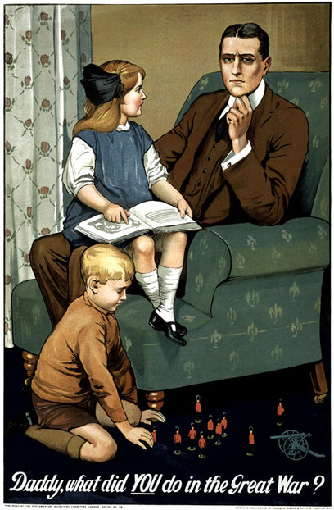
Parliamentary Recruiting Committee. (1915). 'Daddy, what did YOU do in the Great War?'. London. © IWM (Art.IWM PST 0311). Source: https://www.iwm.org.uk/collections/item/object/17053
Demonstrating interpretation of propaganda posters in your writing:

This propaganda poster produced by the British government in 1915 sought to persuade British citizens to enlist for military service. It does this by employing a range of propaganda techniques. First of all, the main character is an idealised middle class British family man. The use of this stereotypical character is an attempt to connect with British middle class men who had not yet joined the war effort. Secondly, the poster uses the symbolism of the toy soldiers, which the young boy is depicted as playing with. The fact that the man's son is more impressed with symbols of war than his own father begins to play on the audience's emotions. Thirdly, the text that accompanies the image, which is spoken by the daughter, inquires about the man's role in the war. The use of the second person pronoun of "you" is a clear attempt to engage personally with the audience. This is reinforced by the fact that the man's eyes are looking directly at the viewer. Therefore, although the girl is talking to her father, the poster intends to directly address the viewer. The clear intent is to make the audience the target of the question so that they will wonder what role they will play in the contemporary conflict. All of these techniques combine with the intention of generating the feelings of shame and guilt in the viewer. The propaganda hopes that young men will feel embarrassed to admit to their future children that they were 'too cowardly' to join the war effort. Even though there is no explicit 'call to action' for the viewer on the poster, the tacit expectation is that the guilt would result in young men enlisting to fight in the hopes of being able to allay the shame produced by the picture. The overall message produced by the propaganda poster is that real men will enlist in the war effort in the belief that their future children will be proud to know that their fathers did their part.

